Project Planner Manual
Project Planner v1.5

Installation 10
Updating Project Planner 10
Supported Unity versions 10
Shortcuts 11
Default 11
Change 11
Menu 12
Board Window 12
Task Window 12
Tree Window 12
Code Analyzer 12
Quick Task 12
Settings 12
Import Demo content 12
Manual 12
GitHub 12
Board Window 13
What is a board? 13
Window 13
Select 13
New 13
Rename 13
Delete 14
Group 15
New 15
Rename 15
Delete 15
Move 15
Duplicate 15
Copy 15
Paste 16
Paste as new 16
Paste values 16
Sort Tasks 16
Name 16
Created 16
Updated 16
Progress 16
Task Window 17
Window 17
Select 17
New 17
Delete 17
Move 18
Copy 18
Paste 18
Paste as new 18
Paste values 18
Duplicate 18
Sections 18
Name 18
Description 19
Tags 19
New 19
Select 19
Delete 19
Rename 19
Colors 19
New 19
Select 19
Delete 20
Change 20
Assigning Assets 20
Add 20
Select 20
Replace 20
Remove 20
Screenshots 20
Add 20
Delete 20
Rename 20
View in Unity 21
View in explorer 21
Subtasks 21
Navigating 21
New 21
Mark as completed 21
Hide completed 21
Locking 21
Lock task 21
Lock task and subtasks 21
Lock all task in group 22
Colors 22
Search by name and description 22
Search by tag 22
Tags popup window options 22
Search by color 22
Colors popup window options 23
Timestamps 23
Tree Window 24
Context Menu 24
Rename Board 24
Delete Board 24
New Group 25
Foldout 25
Dragging 25
Left 25
Right 25
Board Ordering 25
Code Analyzer Window 26
Scan 26
Scan words 26
Not implemented exception 27
Find 27
Make Task 27
Search 27
Foldout 27
Hide files 27
Quick Task Window 28
Select Board 28
Select Group 28
Name 28
Description 28
Subtasks 28
Add 29
Add and close 29
Settings window 30
Popup Windows 31
Options 31
Tags popup window 31
Undo 31
New 31
Select 31
Delete 31
Rename 32
Search 32
Colors popup window 33
Undo 33
New 33
Select 33
Delete 33
Change 33
Assets popup window 34
Undo 34
Add 34
Select 34
Replace 34
Remove 34
Demo Content 35
Folder Structure 36
How to move 36
Menu.cs 36
Data files 36
Temporary assets files 36
Permanent json file 36
Screenshot files 37
Manually Backup 37
Merging and Source Control 37
Language files 37
Language 38
Default language 38
Edit 38
New 38
Undo 39
Effect on your project 39
Editor 39
Build 39
Settings 40
Board Window 40
Allow multiple windows 40
Board name in window tab 40
Minimum height 40
Minimum width 40
Utility 40
Group 40
Drag threshold 40
Fixed width 41
Fixed height 41
Grid 41
Height 42
Hide empty when searching 42
Place new 43
Task 43
Description indicator 43
Drag threshold 43
Min height 43
Show description indicator 43
Task Window 44
Auto dock with board 44
Description fixed height 44
Description height 44
Foldout animation 44
Minimum height 44
Minimum width 44
Show timestamps 44
Utility 44
Tree Window 44
Group 44
Drag threshold 44
Hide empty when searching 45
Task 45
Description indicator 45
Drag threshold 45
Show description indicator 45
Coloring 45
Row Coloring 45
Same -> Color 45
Alternating -> Even 45
Alternating -> Odd 45
By Type -> Board 45
By Type -> Group 45
By Type -> Task 45
By Type -> Subtask 46
Row style 46
Board General 46
Default name 46
Default groups 46
Group General 46
Default name 46
Task General 46
Auto select new 46
Default name 46
Tags 46
Enabled 46
Confirm removal 46
Show by default 47
Colors 47
Enabled 47
Confirm removal 47
Icon type 47
Show by default 47
Assets 47
Enabled 47
Confirm removal 47
Show by default 47
Screenshots 48
Enabled 48
Auto view new 48
Background color 48
Confirm removal 48
Default name 48
Show by default 48
Utility window 48
Subtasks 48
Enabled 48
Show by default 48
Show individual progress 48
Show progress bar 49
Show progress in board window 49
Locking 49
Enabled 49
Show indicator 49
-Color 49
-Subtask color 50
Code analyzer 50
Double click to find 50
Foldout open by default 50
Find not implemented exception 50
Hide files 50
Scan words 50
Scan words are case sensitive 50
Selectable message 50
Show select file button 50
Show scan word with message 50
Use threads 50
Scan after compiling 51
Scan on window open 51
Include file name in search 51
Utility 51
Others 52
Adaptive mouse cursor 52
Hide UI when dragging 52
Language 52
Show window title icon 52
Support undo 52
Reset 53
Compatibility 54
Newtonsoft.Json.dll 54

Installation
Before installing Project Planner, make sure asset serialization mode is set to “Force Text”.
You can find the setting here “Edit->Project Settings->Editor->Asset Serialization”.

To install Project Planner you can either download the entire project from GitHub and copy the Project Planner root folder into your own Assets folder. You can also (recommended) download the .unitypackage file and import that into your unity project.

Updating Project Planner
When updating, always make a backup of your Project Planner data in case your Unity project is not compatible with the new version. You should also close all Project Planner windows before importing the update.

If you need an older version of Project Planner that is not available on the Asset Store, you can write to me, and I will send it to you.

Supported Unity versions
Unless Unity makes a significant change to the editor in a version, Project Planner should work on all Unity versions after version 2017.4.19.

Shortcuts

Default
Ctrl+Alt+B
Open the board window.

Ctrl+Alt+T
Open the task window.

Ctrl+Alt+Q
Open the quick task window

Change
If you are using Unity 2019 or later, you can ignore the instructions below and use Unity's shortcut manager instead.

If you want to change the shortcuts used by Project Planner you need to edit the MenuItem attributes in the Menu.cs file. You can read about how to locate the Menu.cs file under “Folder Structure”. If you are not sure how to use a MenuItem attribute I recommend reading Unity's documentation here: https://docs.unity3d.com/ScriptReference/MenuItem.html

Menu
You can find the Project Planner menu in the menu bar at the top under Tools->Project Planner.

Board Window
Opens the board window.

Task Window
Opens the task window.

Tree Window
Opens the tree window.

Code Analyzer
Opens the code analyzer window.

Quick Task
Opens the quick task window.

Settings
Opens the settings window.

Import Demo content
Imports demo content.

Manual
Opens the manual in your default pdf viewer.

GitHub
Opens the Project Planner GitHub page.

Board Window

What is a board?
A board is a collection of tasks that are organized into groups. A board is not meant to contain every task you ever make. A board should represent a period of time or a specific area of work.

Window
In the board window, you can view and edit the contents of your boards.It is a good idea to dock the board window somewhere with a lot of space as it quickly gets filled up with groups.
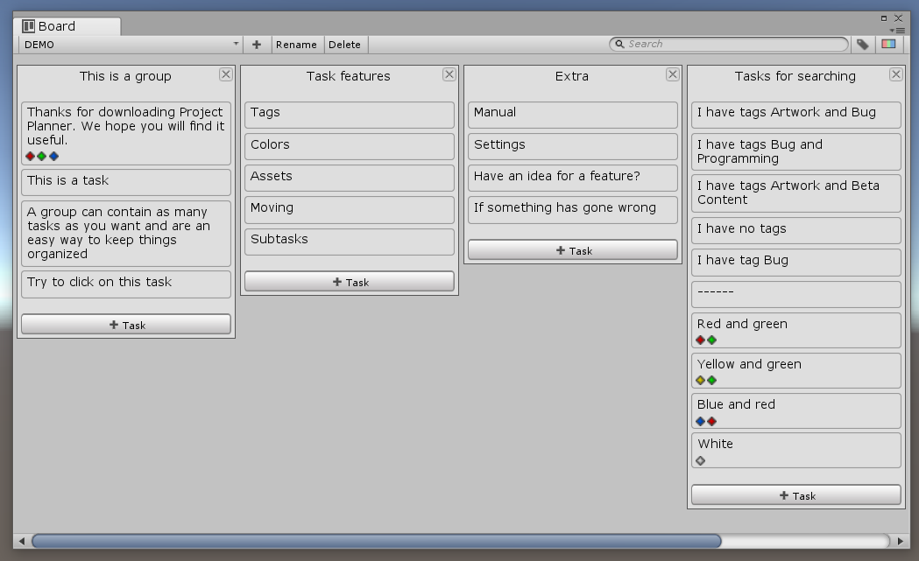

Select
To select a board click on the button with the currently selected board's name in the board window toolbar. When you click a context menu appears with all the boards you can select.
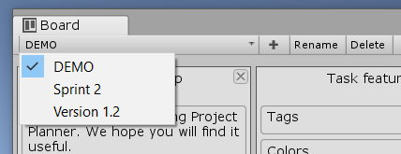

New
To create a new board click on the button in the board window toolbar.

Rename
All board names must be unique. If you try to enter a name that is already taken a numeric prefix will be added.

With the board you want to rename selected, click on the “Rename” button in the board window toolbar. When you have clicked the rename button the select board button is replaced with a text field where you can edit the board's name. When you are done press the enter key or click outside the text field.
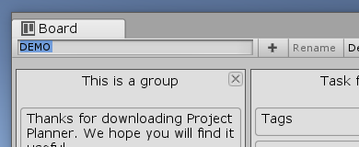
When you name a board, you can use “/” to create submenus in the select board menu.
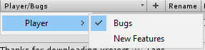

Delete
With the board you want to delete selected, click on the “Delete” button in the board window toolbar. If a board contains a task that is locked the delete button is disabled.

Group

New
To make a new group click on the “New Group” button in the board window toolbar. You can choose where to place new groups in the settings. By default, they are placed last.

Rename
All group names must be unique. If you try to enter a name that is already taken a numeric prefix will be added.

To rename a group double click or right click on the groups name and select “Rename” in the context menu. The name is replaced with a text field where you can edit the group name. When you are done, press the enter key or click outside the text field.

Delete
To delete a group click on the button in the top right corner of the group you want to delete or right click on the group name and select “Delete” in the context menu.

Move
To move a group hold click on its name and drag it to where you want it. The group that is being moved around has an extra margin at the top. You can also move a group left or right by right-clicking on its name and selecting “Move left” or “Move right.”

If you want to move a group to another board right-click on its name and select “Move to board” and then the name of the board you want to move to.

Duplicate
To duplicate a group right click on its name and select “Duplicate” in the context menu.

Copy
To copy a group right click on its name and select “Copy” in the context menu.

Paste
When pasting a group, you have two options. You can make a new copy or replace an existing group with the copied group.

Paste as new
- Right click on a group name and select “Paste as new”. The new group will be placed after the one you right clicked on.
- Right click on the “New Group” button in the board window toolbar and select “Paste as new”. The new group will be placed in the same way as if you had used the new group button normally.

Paste values
To replace the values of a group with the copied group ’s values, right click on a group and select “Paste values” in the context menu.

Sort Tasks
To sort tasks in a group right click on the group name, select “Sort” and then how you want to sort the tasks. When sorting it does not matter if a task is locked or not.

Name
- ASC: Alphabetical order.
- DESC: Reverse alphabetical order.

Created
- ASC: Newest first.
- DESC: Oldest first

Updated
- ASC: Most recently updated first.
- DESC: Least recently updated first.

Progress
- ASC: Most progress first.
- DESC: Least progress first.

Task Window

Window
In the task window, you can view and edit a task. The task window takes up a lot of space vertically. A good place to dock the task window is with the inspector.
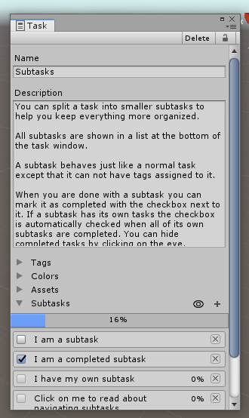

Select
You select a task by clicking on it or by right-clicking and selecting “Edit” in the context menu. If the task window is closed when you select a task, it will open. If the task window is already open, it will be focused.

New
To make a new task click on the 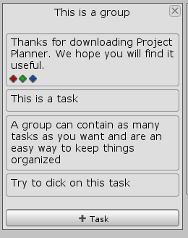 button at the bottom of the group you want to add the task to or right click on a group name and select “New task” in the context menu.

Delete
To delete a task click on the “Delete” button in the task window toolbar or right click on a task and select “Delete” in the context menu.

If you delete a subtask using the delete button in the task window its parent task will be selected.

Move
To move a task hold click on its name and drag it to where you want it. You can also right click and select “Move up” or “Move down” in the context menu. The task that is being moved around has an extra margin to the sides.

If you want to move a task to a group in another board right-click on it and select “Move to group” then the name of a board and then the name of the group you want to move to.

Copy
To copy a task right click on it and select “Copy” in the context menu.

Paste
When pasting a task, you have two options. You can make a new copy or replace an existing task with the copied task.

Paste as new
- Right click on a task and select “Paste as new”. The new task will be placed after the one you right clicked on.
- Right click on a group name and select “Paste task”. The new task is placed first.
- Right click on the new subtask button and select “Paste task”. The new subtask is placed first.

Paste values
To replace the values of a task with the copied task’s values, right click on a task and select “Paste values” in the context menu.

Duplicate
To duplicate a task right click on it and select “Duplicate” in the context menu.

Sections
Below the description, the task window is split into sections. You can toggle the visibility of a section by clicking on the arrow to the left of its name. If you don't use a feature you can disable it in the settings and the section for that feature will not appear anymore.

Name
The task name is used in the board window to show a task. Try to keep the name short and precise, so it does not take up to much space in the board window.

If the task does not have a name the text “NO NAME” will be used instead.

Description
The description is where you write down in detail what needs to be done to complete the task. If you feel like the description is getting too big, consider splitting the task up into smaller subtask.

If a task has a description, an indicator is added to the end of the task name. By default “...” is added. You can disable this feature or edit the indicator text in the settings.

Tags

New
To add a new tag you first write the name of your new tag in the text field below the list of tags, you then click on the add button to the right. You can not have more than one tag with the same name. Tags are not case sensitive.
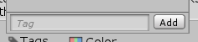

Select
You can select a tag by clicking on the toggle button to the left of it . A tag is selected when they are a checkmark in the button.

Delete
To delete a tag click on the button to the right of the tag you want to delete. Tags are shared so if you delete a tag it will affect every task with that tag.

Rename
To rename a tag just change the content of the text field with the tags name in it.

Colors
Colors are displayed with the task name in the board window and in the list of subtasks.
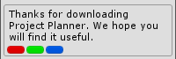

New
You can add a new color by clicking on the white area at the bottom of the list of colors. After clicking, a color picker appears where you can select the color you want. When you are done selecting a color, click on the add button to the right.
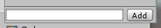

Select
You can select a color by clicking on the toggle button to the left of it. A color is selected when they are a checkmark in the button.

Delete
To delete a color click on the button to the right of the color you want to delete. Colors are shared so if you delete a color it will affect every task with that color.

Change
To change a color click on it and select the new color in the color picker that appeared.

Assigning Assets

Add
You can add an asset by clicking on the small circle to the left of the empty object field where it says “None (Object)”. You can add the same asset multiple times.

Select
To select an asset click on it. When you click on an asset it will be highlighted and selected in the Project view.

Replace
You can replace an asset by clicking on the circle to the left of it and select a new asset.

Remove
To remove an asset click on the button to the right of the asset you want to remove. You can also click on it and press the delete key.

Screenshots

Add
You can add a screenshot to a task by clicking on the icon to the right of where it says screenshots. In order to add a new screenshot, the game view must be selected. Project Planner tries to select the game view for you automatically.

Delete
To delete a screenshot click on the button to the right of the screenshot you want to remove. You can also delete a screenshot by first clicking on the “View” button and then the “Delete” toolbar button in the screenshot window.

Rename
To rename a screenshot just change the content of the text field with the screenshot name in it.
You can also rename a screenshot by first clicking on the “View” button and using the text field to the left in the screenshot window toolbar.

View in Unity
You can view a screenshot by clicking on the “View” button to the right of the screenshot. A new window will appear with your screenshot.

View in explorer
You can also view the screenshot using your own image viewing software by first clicking on the “View” button and then the “Open in explorer” toolbar button in the screenshot window.

Subtasks
The way a subtask behaves and how you interact with it is almost the same as a normal task. The differences are described below.

Navigating
When viewing a subtask two extra buttons are available in the toolbar to the left. The first button is named “Back”. The back button takes you back to the parent of the task you are viewing. The second button is named “Go to”. The go to button shows you a list of all task leading back to the first task. This is useful if you have a lot of nested tasks.

New
You can add a subtask to a task by clicking on the icon to the right of where it says subtasks.

Mark as completed
When you are done with a subtask you can mark it as completed by clicking on the button to the left of the subtask. If the subtask also has subtasks the button cannot be toggled manually.

Hide completed
You can hide completed subtasks by clicking on the eyeabove the subtasks. The eye is green when completed subtasks are hidden.

Locking
When a task is locked, you cannot edit, delete or move it, and all empty fields will be hidden. You can also not delete any object that has a locked task in it. Example: If you have a board with a locked task in it, the board cannot be deleted.

Lock task
- Click on the button in the top right corner of the task window.
- Right click on a task and select “Lock/Lock” or “Lock/Unlock” in the context menu.

Lock task and subtasks
This operation is recursive so if a subtask has its own subtasks, they will also be affected.
- Right click on the button in the top right corner of the task window and select “Lock including subtasks” or “Unlock including subtasks”.
- Right click on a task and select “Lock/Lock including subtasks” or “Lock/Unlock including subtasks” in the context menu.

Lock all task in group
- Right click on the group name and select “Lock/Lock tasks” or “Lock/Unlock tasks” in the context menu.

Colors
When a task is locked, a colored line is shown to the left of the task name. You can disable this feature or edit the colors used in the settings.

A dark line means the task itself is locked.
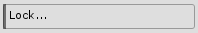
A grey line means the task contains a subtask that is locked.
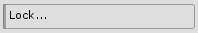

Search by name and description
Too filter what task to show by their name and description write your search query in the text field with the small magnifying glass in the right side of the toolbar. Searching is not case sensitive.
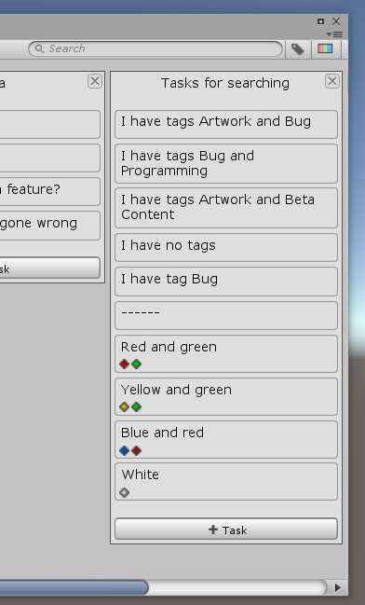
When searching you can specify if you want to search by name or description only by writing "n:" (only name), “d:” (only description) followed by your search query.

Search by tag
To filter what task to show by their tags click on the 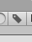button on it in the right side of the toolbar. A popup window appears where you can select your tags.

Tags popup window options
Reset: marks all tags as not selected.
Task has all selected: if true a task has to include all selected, if false it just has to include one.

Search by color
To filter what task to show by their color click on the 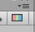button on it in the right side of the toolbar. A popup window appears where you can select your colors.

Colors popup window options
Reset: marks all colors as not selected.
Task has all selected: if true a task has to include all selected, if false it just has to include one.

Timestamps
Timestamps show when a task was created and when it was last updated. The timestamps are located at the bottom of the task window. By default timestamps are hidden, this can be changed in the settings.

Tree Window
The tree window is an alternative to the board window. The two main differences between the board and tree window are that all boards and subtasks a shown and that everything is flowing downwards in a tree structure.
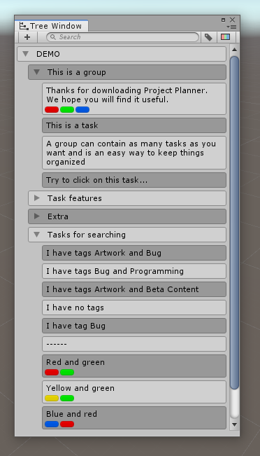

The way you interact with boards, groups, and tasks are a lot like you do in the board window. If you want to learn how to do something you can find the answer under the Board Window section of the manual. The differences between the board and tree window are described below.

Context Menu
Most of what you can do in the tree window is done using the context menu. You can open the context menu by right-clicking on a board, group, or task.

Rename Board
To rename a board double click or right click on the boards name and select “Rename” in the context menu. The name is replaced with a text field where you can edit the board name. When you are done, press the enter key or click outside the text field.

Delete Board
To delete a board right click on the board name and select “Delete” in the context menu.

New Group
To make a new group right click on a board name and select “New group” in the context menu.

Foldout
All rows that have other rows under them has an arrow to the right that toggles the visibility of the sub rows. When searching all relevant rows are shown no matter the toggle state.

Dragging
When dragging groups and tasks around it makes a difference what side of a row the cursor is over.

Left
The row hides its sub rows. If you are dragging a task it is placed together with the task the cursor is over.

Right
The row shows its sub rows. If you are dragging a task it is placed as a subtask of the task the cursor is over.

Board Ordering
The boards are ordered in alphabetical order and cannot move moved.

Code Analyzer Window
The code analyzer can search through all your scripts and find comments that starts with specific words like “TODO”. It can also find not implemented exceptions and list them in the code analyzer window.
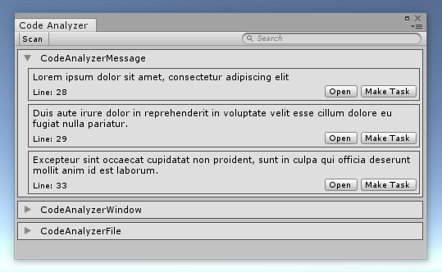

Scan
The content of the window is not updated in real-time and need to scan your scripts in order to reflect the correct information. To manually run a scan click the “Scan” button in the toolbar. You can also configure the code analyzer to automatically run when compiling scripts. This is on by default.

Scan words
When scanning the code analyzer looks for comments starting with a scan word. You can change the scan words in the settings. The word has to be part of a // comment and in the beginning.
By default, scan words are not case sensitive. This can be changed in the settings.

Here is an example of a comment that will be found.
24. //TODO Make into a property later
25. public Rect rectAbsolute;

Not implemented exception
When scanning, the code analyzer can also find not implemented exceptions. This can be changed in the settings but is on by default. The code analyzer is more flexible when looking for exceptions then with scan word. It does not have to be on a line by itself. As long as “new NotImplementedException” is part of a line it will be found.

Here is an example of a not implemented exception that will be found.
32. public void KillThePlayer()
33. {
34. throw new NotImplementedException();
35. }

Find
You can find a comment or exception by clicking on the “Find” button or by double-clicking anywhere in the box. When you use the find feature the code analyzer will open the file the result is from and jump to the line it is on.

Make Task
You can make a result into a task by clicking on the “Make Task” button. After clicking you have to select what group you want to place the task in. You can add the same result multiple times.

The task ́s name will be the comment in your code. Its description is the name of the file and the line it was on. The task will also have the script assigned as an asset.

Search
You can filter what results to see by using the search field in the toolbar.

Foldout
You can hide the results of a file by clicking on the arrow in the top left corner of the box belonging to that file. If you want to show the content again click the arrow. By default, the foldout is set to show.

Hide files
You can hide files with a specific name in the settings under “Settings->Code analyzer->Hide files”

Quick Task Window
The quick task window is designed to do two things. The first is to make it easier to create multiple tasks right after each other without having to use the mouse. The second is to add a new task without having to leave what you are doing to find the board and task window. When you open the window, it will always center itself in the middle of the screen.
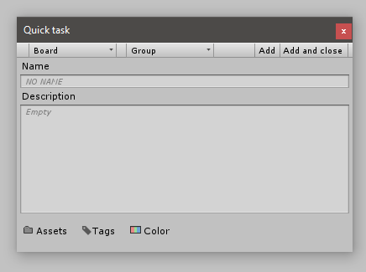

Select Board
Click on the first button with a small arrow in the toolbar to the left. When you click a context menu appears with all the boards you can select.

Select Group
After selecting a board, you have to pick a group to place the task in. Click on the second button with a small arrow in the toolbar to the left. When you click a context menu appears with all the groups from the selected board.

Name
The name field ignores the default task name setting. The name field is automatically selected when you use the shortcut to open the window and after you add a task.

Description
The description field ignores the fixed description height setting. You can select the description field by pressing the tab key while the name field is selected.

Subtasks
You can not make subtasks in the quick task window. If you want to add subtasks you have to use the task window.

Add
When you are ready to add your task click on the “Add” button to the right in the toolbar, you can also use the shortcut “Ctrl+Enter”. After you add a task, the quick task window will reset and select the name field, so you are ready to add a new task again. If you want to close the window after adding a task, click the “Add and close” button.

Add and close
The “Add and close” button to the right in the toolbar behaves in the same way as the “Add” button except that it closes the window instead of resetting it. You can use the shortcut “Ctrl+Alt+Enter” to activate it.

Settings window
Project Planner has two settings windows you can use. The windows contain the same settings and are synchronized with each other, so the only difference is where they are located.

The first is Project Planners own window and can be found by going to Tools->Project Planner->Settings. You can also access the settings from the window menus.
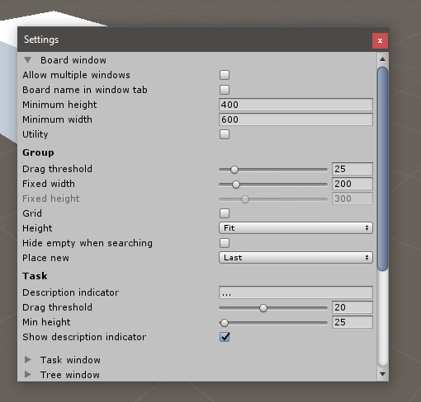

The second is Unity ́s build in preferences window and can be found by going to Edit->Preferences->Project Planner.
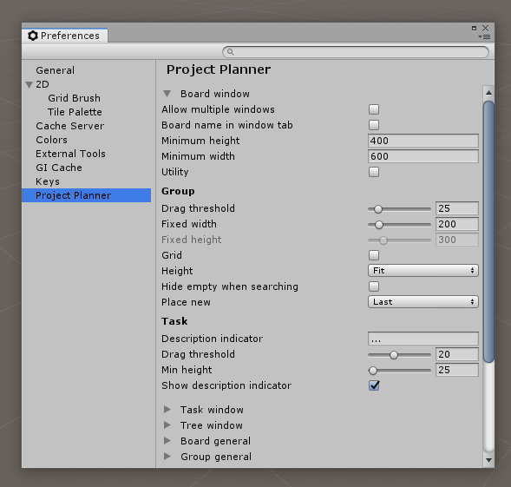

You can read more about what the settings do under “Settings”

Popup Windows

Options
Sometimes when you open a popup window you have some extra options to choose from. If extra options are available the 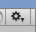button appears on the right side of the toolbar. When you click the button a menu appears under the toolbar with the options. You can hide the menu again by clicking on the button.

Tags popup window
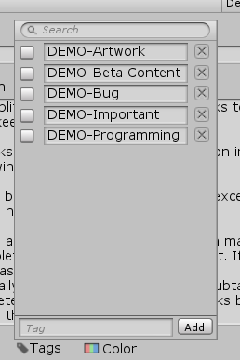

Undo
When you close the popup window all undo operations inside the window is merged into one single undo action.

New
To add a new tag you first write the name of your new tag in the text field at the bottom of the window, you then click on the add button to the right. You can not have more than one tag with the same name. Tags are not case sensitive.


Select
You can select a tag by clicking on the toggle button to the left of it . A tag is selected when they are a checkmark in the button.

Delete
To delete a tag click on the button to the right of the tag you want to delete. Tags are shared so if you delete a tag it will affect every task with that tag.

Rename
To rename a tag just change the content of the text field with the tags name in it.

Search
You can filter what tags to show in the window by writing your search query in the text field at the top of the window.
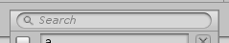

Colors popup window
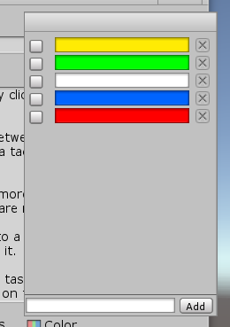

Undo
When you close the popup window all undo operations inside the window is merged into one single undo action.

New
You can add a new color by clicking on the white area at the bottom of the window. After clicking, a color picker appears where you can select the color you want. When you are done selecting a color, click on the add button to the right.


Select
You can select a color by clicking on the toggle button to the left of it. A color is selected when they are a checkmark in the button.

Delete
To delete a color click on the button to the right of the color you want to delete. Colors are shared so if you delete a color it will affect every task with that color.

Change
To change a color click on it and select the new color in the color picker that appeared.

Assets popup window
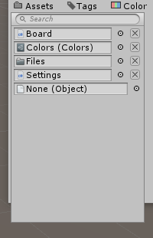

Undo
The asset popup window does not support Unity’s undo system when adding and removing assets. When you close the window everything you have done will be saved as a single undo action.

Add
You can add an asset by clicking on the small circle to the left of the empty object field where it says “None (Object)”. You can add the same asset multiple times.

Select
To select an asset click on it. When you click on an asset it will be highlighted and selected in the Project view.

Replace
You can replace an asset by clicking on the circle to the left of it and select a new asset.

Remove
To remove an asset click on the button to the right of the asset you want to remove. You can also click on it and press the delete key.
Search
You can filter what assets to show in the window by writing your search query in the text field at the top of the window. When searching you can show a specific type of asset by writing "t:" followed by the type of assets you want.
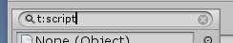

Demo Content
Project Planner comes with demo content that is designed to guide you through the essential features and how to use them. If you are new to Project Planner and the kind of person that learns best by example I recommend that you have a look at the demo content.

To import the demo content click on Tools->Project Planner->Import | Export->Demo Content. The import process will not override any existing data. The demo content adds the tags “DEMO-Artwork”, “DEMO-Beta" Content”, “DEMO-Bug”, “DEMO-Programming”, “DEMO-Important” and the colors red, blue, green, yellow and white. A new board named “DEMO” is added. If everything has been imported correctly, the demo board should look like the image below.
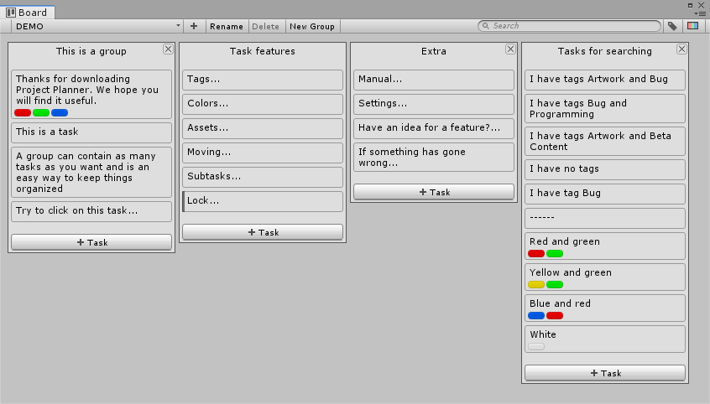
All demo content is named with the prefix “DEMO” to make it easy to locate and delete again. If you import the demo content more then once, the demo tasks will share the same tags and colors, but each board will be named DEMO with a numeric postfix.

Folder Structure
When you import Project Planner a new folder named “Project Planner” is created in your assets folder.

How to move
You can move the Project Planner folder to wherever you want inside the assets folder. When you move the folder, you have to be sure that you move the folder with the project_planner_locator file in it and that you keep the same folder structure inside the Project Planner folder.

Menu.cs
The menu.cs file is located at "Project Planner/Editor/Menu.cs". The reason Menu.cs is outside the DLL file is so you can change the shortcuts used by Project Planner. You can read more about how to change the shortcuts under “Shortcuts”

Data files

Temporary assets files
While working in the editor, all data is stored as ScriptableObjects (.asset files) inside the “Project Planner\Editor\Data” folder. This is because it is fast to read and write to assets files, but the data here is only temporary and is frequently overwritten or cleared.

Permanent json file
When Unity performs a save event like saving a scene, the project, or closing, the data from the .asset files are combined and saved as .json in a folder called “Project Planner” in your project root folder. The .json file is used to store data that needs to persist between Unity sessions.

The .json file does not follow the standard JSON format, so if you want to read the content of the file, there are a few things you need to know. Each line contains an ID prefix followed by one of the .asset files as standard JSON. Below is a list of IDs and their corresponding .asset files.
00 - Boards
01 - Groups
02 - Tasks
03 - Tags
04 - Colors

I recommend https://jsonformatter.curiousconcept.com if you want to format the JSON to make it easier to read.

Screenshot files
All task screenshots are saved in “{your project root folder}/Project Planner/Screenshots/{task id}/”. While working in unity two extra folders called “tmp” and “copy” will sometimes appear. The two extra folders will disappear again when you close Unity.

Manually Backup
If you want to manually backup your data you have to make a copy of the .json file, not the .asset files. To make sure everything has been saved fully it is a good idea to save your project manually by selecting “File->Save Project” in the top Unity menu.

If you want to restore a backup manually, close Unity, then replace the .json file and reopen Unity. If you replace the file while Unity is open, it will be overwritten by the .asset files when a save event triggers.

If any of your tasks has screenshots on them you also need to make a copy of the screenshots folder. The folder is in the same location as the .json file.

Merging and Source Control
If you are using source control like Git and want to commit your changes, you first have to trigger a save event. You can do this by saving a scene, the entire project, or closing Unity. When you have triggered a save event you can commit the .json file in the “Project Planner” folder in your project root folder. It does not matter if you commit the .asset files in “Assets\Project Planner\Editor\Data” folder.

When merging two .json files, it is always recommended to use everything from one file only to avoid missing references. If you need to or by mistake merge two .json files and breaks references, Project Planner will be able to recover most of the data most of the time, but this is not something you should rely on. A more effortless merging system will be added in a later update.

Language files
The language files used by Project Planner are saved as .asset files inside the “Project Planner\Editor\Language” folder. If you want to add your own language file its has to be placed inside this folder.

Language

Default language
English is the default language. It is not possible to remove English as a language. If Project Planner is not able to find the English language file, it will auto-generate a new one.

Edit
To edit a language file, you first have to select it in the Project window. When selected a list with all the words and sentences used by Project Planner in alphabetical order is shown in the inspector window. The Inspector window has a label and a text field for every word/sentence. The label is the original text in English, and the text field is the text used by Project Planner. You can search for translations using the search text field in the top of the inspector window.
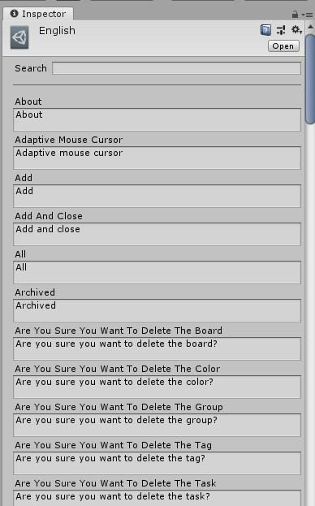

New
You can add your own language to Project Planner by right-clicking on the language folder and then Create->Project Planner->Language in the context menu. You can read more about how to find the language folder under “Folder Structure”.
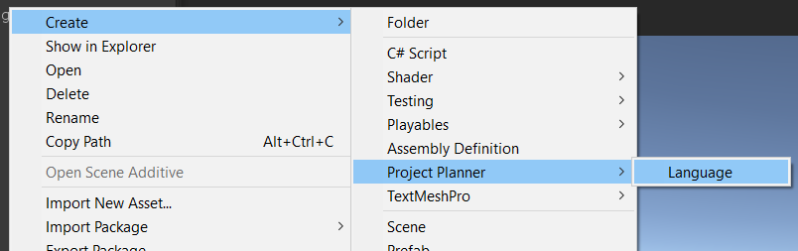

Undo
Project Planner supports Unity’s undo system so every action you do in the board and task window can be undone again. When you close both the board and task window all undo operations related to Project Planner is cleared. You are not able to undo changes made in the settings window.

Effect on your project

Editor
A lot of the data used by Project Planner is not written to the disk until Unity triggers a save event like saving the project, a scene, or when closing. I do this to avoid freezing the editor while you are working, but it also means that if you have been working for a long time and manipulated a lot of data, it may take a few seconds longer to perform some of the above mansion actions than usual.

Project Planner does not affect your compile time when you make changes to your code because it comes precompiled.

Build
Project Planner will not affect your game performance or size because Unity ignores 99% of all Project Planner files when compiling your game.

Settings

Board Window

Allow multiple windows
Default: false
If true, you can have multiple board windows open at the same time; else the existing window will be focused when trying to open a new.

Board name in window tab
Default: false
If true, the board window tab will display the name the selected board.

Minimum height
Default: 400
Minimum height the board window can be.

Minimum width
Default: 600
Minimum width the board window can be.

Utility
Default: false
Show the board window as a utility window. A utility window cannot dock with other windows or be maximized.

Group

Drag threshold
Default: 25
The distance in pixels you have to move the mouse when drag moving a group before it registers.

Fixed width
Default: 200
The width of a group in pixels.
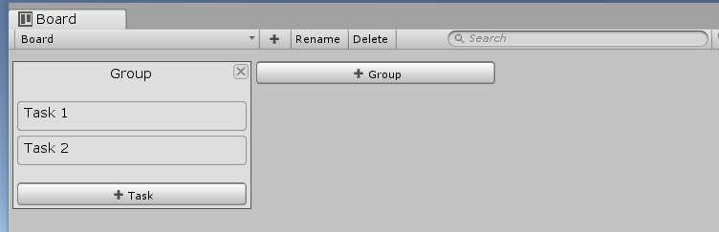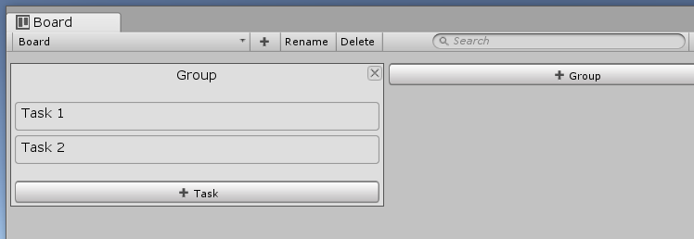

Fixed height
Default: 300
The height of a group in pixels when “Fixed” is selected in the height setting.

Grid
Default: false
Display groups in a grid instead of a horizontal line.
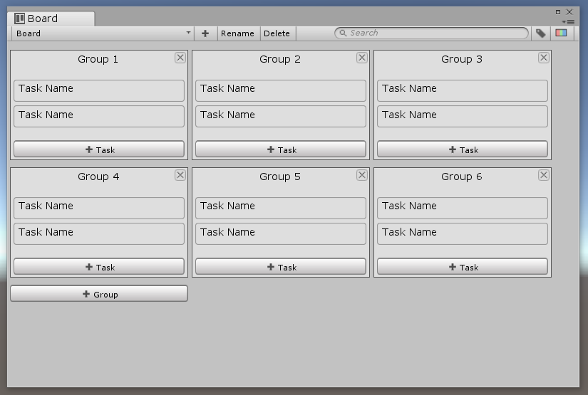

Height
Default: Fit
How the height of a group is calculated.

Fit: Has the exact height needed to show the content of the group.
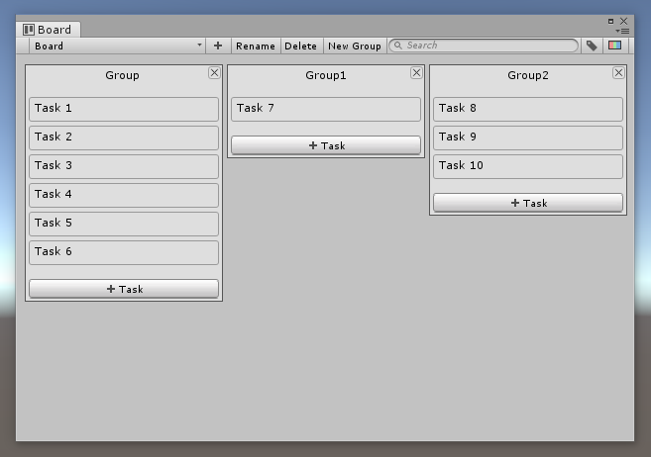
Fixed: Has the same height no matter the content of the group.
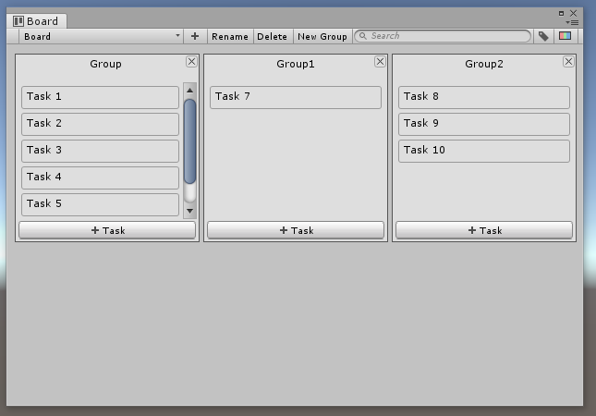
Fill: Fills the entire height of the window no matter the content of the group.
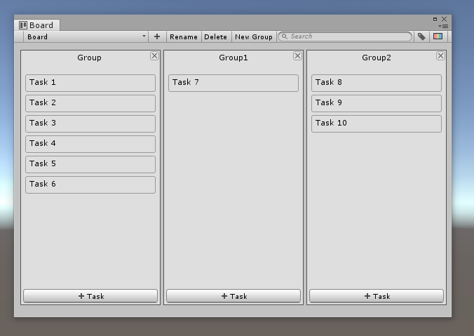

Hide empty when searching
Default: false
When searching hide groups that do not have any task shown in them.

Place new
Default: Last
Where to insert a new group.

Task

Description indicator
Default: ...
What is added to a task name of the task has a description.

Drag threshold
Default: 20
The distance in pixels you have to move the mouse when drag moving a task before it registers.

Min height
Default: 25
The minimum height in pixels a task can have.
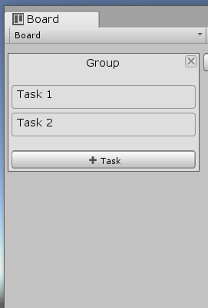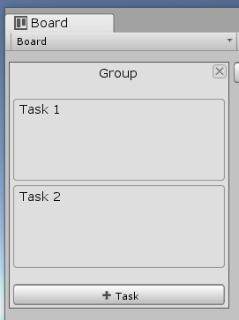

Show description indicator
Default: true
Add an indicator to a task name if the task has a description.

Task Window

Auto dock with board
Default: false
The task window tries to place itself in the same location as the board window when it opens.

Description fixed height
Default: true
Does the task description have a minimum height? If false the text field will try to fit the content.

Description height
Default: 15
Is only shown if “Fixed description height” is true. The minimum height a tasks description field can be.

Foldout animation
Default: true
If true, apply a smooth animation when toggling sections in the task window.

Minimum height
Default: 400
Minimum height the task window can be.

Minimum width
Default: 300
Minimum width the task window can be.

Show timestamps
Default: false
Show when the task was created and the last time it was updated.

Utility
Default: false
Show the task window as a utility window. A utility window cannot dock with other windows or be maximized.

Tree Window

Group

Drag threshold
Default: 25
The distance in pixels you have to move the mouse when drag moving a group before it registers.

Hide empty when searching
Default: false
When searching hide groups that do not have any task shown in them.

Task

Description indicator
Default: ...
What is added to a task name of the task has a description.

Drag threshold
Default: 20
The distance in pixels you have to move the mouse when drag moving a task before it registers.

Show description indicator
Default: true
Add an indicator to a task name if the task has a description.

Coloring

Row Coloring
Default: By Type
How to apply color to rows in the tree window.

Same -> Color
Default: FFFFFF
The color of all rows.

Alternating -> Even
Default: FFFFFF
The color of all the even rows.

Alternating -> Odd
Default: 808080
The color of all the odd rows.

By Type -> Board
Default: FFFFFF
The color of a board.

By Type -> Group
Default: 808080
The color of a group.

By Type -> Task
Default: 333333
The color of a task.

By Type -> Subtask
Default: 333333
The color of a subtask.

Row style
Default: Box 1
The image a row use for its background.

Board General

Default name
Default: Board
The default name a board have when it is created.

Default groups
Default: Planned, In Progress, Testing, Completed.
List of groups a board has when it is created.

Group General

Default name
Default: Group
The default name a group have when it is created.

Task General

Auto select new
Default: true
Automatically select task and open the task window when a new task is created..

Default name
Default: Task
The default name a task have when it is created.

Tags

Enabled
Default: true
If false the task tag feature will not be available.

Confirm removal
Default: false
When you try to remove a tag, a dialog appears asking if you are sure.

Show by default
Default: false
When a new task is created, the tags section is visible.

Colors

Enabled
Default: true
If false the task color feature will not be available.

Confirm removal
Default: false
When you try to remove a color, a dialog appears asking if you are sure.

Icon type
Default: Box
The type of icon used to show task colors with.
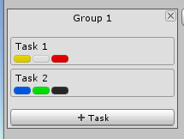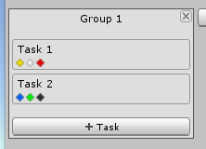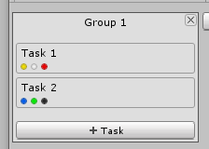

Show by default
Default: false
When a new task is created, the colors section is visible.

Assets

Enabled
Default: true
If false the assigning assets to tasks feature will not be available.

Confirm removal
Default: false
When you try to remove an assigned asset, a dialog appears asking if you are sure.

Show by default
Default: false
When a new task is created, the assets section is visible.

Screenshots

Enabled
Default: true
If false the screenshots feature will not be available.

Auto view new
Default: false
If true the screenshot window will appear when a new screenshot is added. This is the same as clicking the view button.

Background color
Default: 000000
The background color of the screenshot window.

Confirm removal
Default: false
When you try to remove a screenshot, a dialog appears asking if you are sure.

Default name
Default: “Screenshot”
The default a new screenshot gets when added.

Show by default
Default: false
When a new task is created, the screenshots section is visible.

Utility window
Default: false
Show the screenshot window as a utility window. A utility window cannot dock with other windows or be maximized.

Subtasks

Enabled
Default: true
If false the subtask feature will not be available.

Show by default
Default: true
When a new task is created, the subtasks section is visible.

Show individual progress
Default: true
If a subtask also has its own subtasks show their progress next to the subtask name.
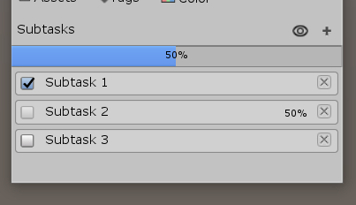

Show progress bar
Default: true
Show a progress bar above all the subtasks.
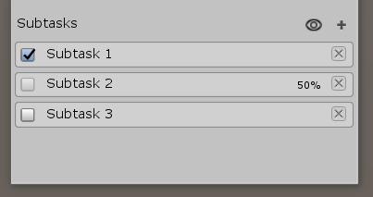

Show progress in board window
Default: true
Show the total subtasks progress under the task name in the board window. If a task does not have any subtasks this setting will be ignored.
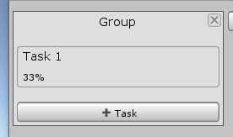

Locking

Enabled
Default: true
If false the locking feature will not be available.

Show indicator
Default: true
Show a line to the left of a task if it is locked or have a locked subtask.

-Color
Default: 0, 0, 0, 128
The lock line color if the task itself is locked.

-Subtask color
Default: 102, 102, 102, 128
The lock line color if the task has a subtask that is locked.

Code analyzer

Double click to find
Default: true
Double-clicking on a result has the same effect as clicking the find button.

Foldout open by default
Default: true
After scanning all file foldouts are set to show.

Find not implemented exception
Default: true
Scan for not implemented exception.

Hide files
Default: Empty
The code analyzer will ignore any file whose name is on the list. The names are not case sensitive.

Scan words
Default: “TODO”
List of words to use when scanning scripts.

Scan words are case sensitive
Default: false
If true scan words are case sensitive.

Selectable message
Default: true
The text in a result box can be selected using the mouse.

Show select file button
Default: false
Show a button that when clicked selects the file a result is from in the project view.

Show scan word with message
Default: false
Add the scan word as a prefix to a result.

Use threads
Default: true
Use threads when scanning scripts.

Scan after compiling
Default: true
Automatically start a scan after Unity is done compiling scripts.

Scan on window open
Default: true
Automatically start a scan when the window is first opened.

Include file name in search
Default: true
Use the file name as part of result searching.

Utility
Default: false
Show the code analyzer window as a utility window. A utility window cannot dock with other windows or be maximized.

Others

Adaptive mouse cursor
Default: true
Change the cursor to a hand icon when it is over something that can be clicked on.

Hide UI when dragging
Default: true
Hide some UI elements when dragging groups or tasks.
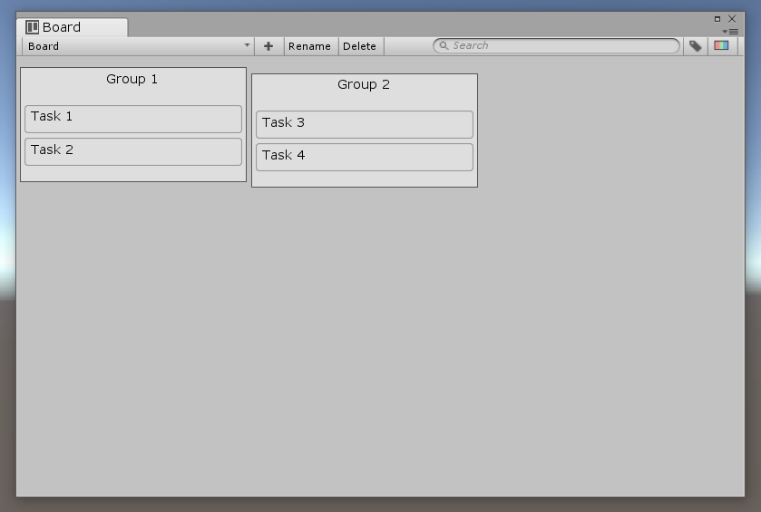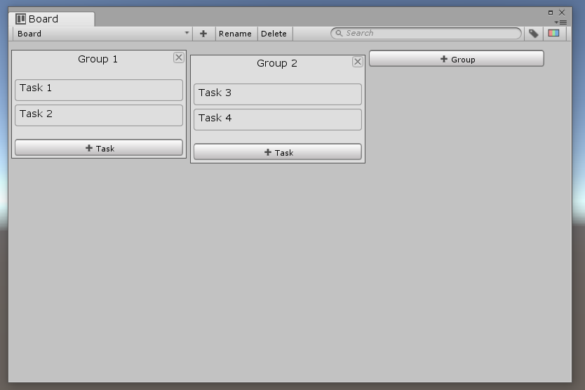

Language
Default: English
The language used by Project Planner.

Show window title icon
Default: true
Show an icon next to the name of the board and task window.
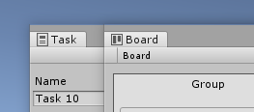

Support undo
Default: true
Integrate Unity’s undo system with Project Planner.

Reset
You can reset all settings to their default values by clicking on the reset button at the bottom of the settings window.

Compatibility

Newtonsoft.Json.dll
When using other packages you may sometimes get an error saying that you have more than one Newtonsoft.Json.dll and are unable to decide which one to use. You can fix it by clicking on Project Planners Newtonsoft.Json.dll and turn editor off under “Include Platforms” in the inspector like in the image below.
